Activity Diagrams
UC_24 – UC_34

UC_24 – Receive Notifications
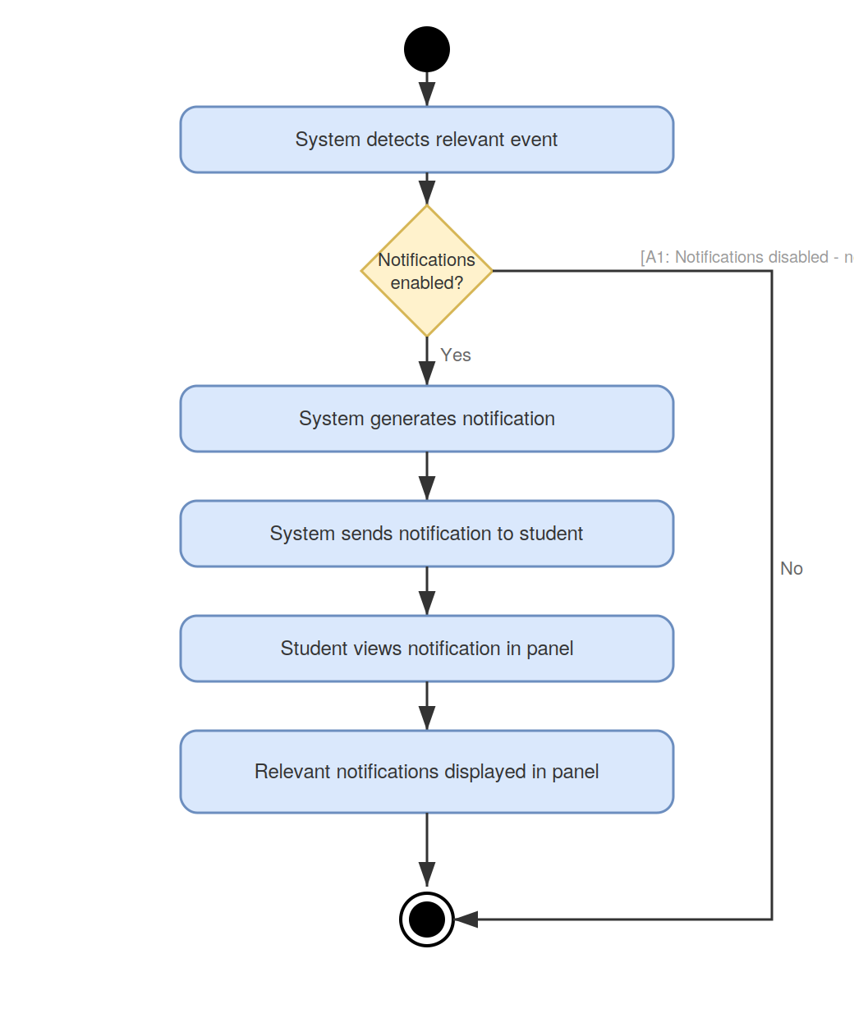

UC_25 – View Lab Roster
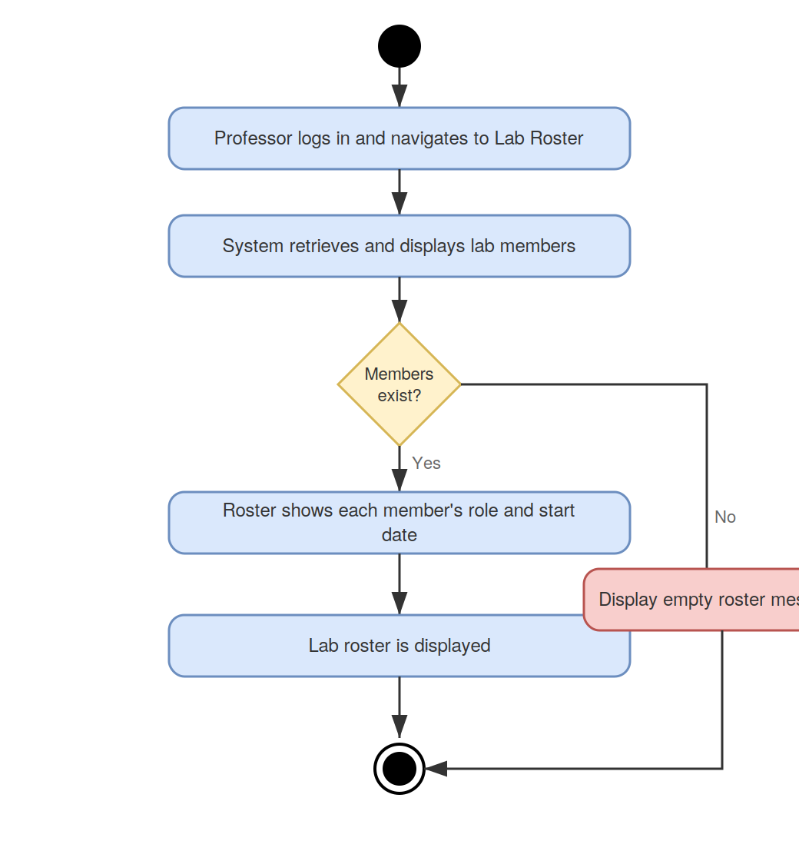

UC_26 – Update Lab Roster
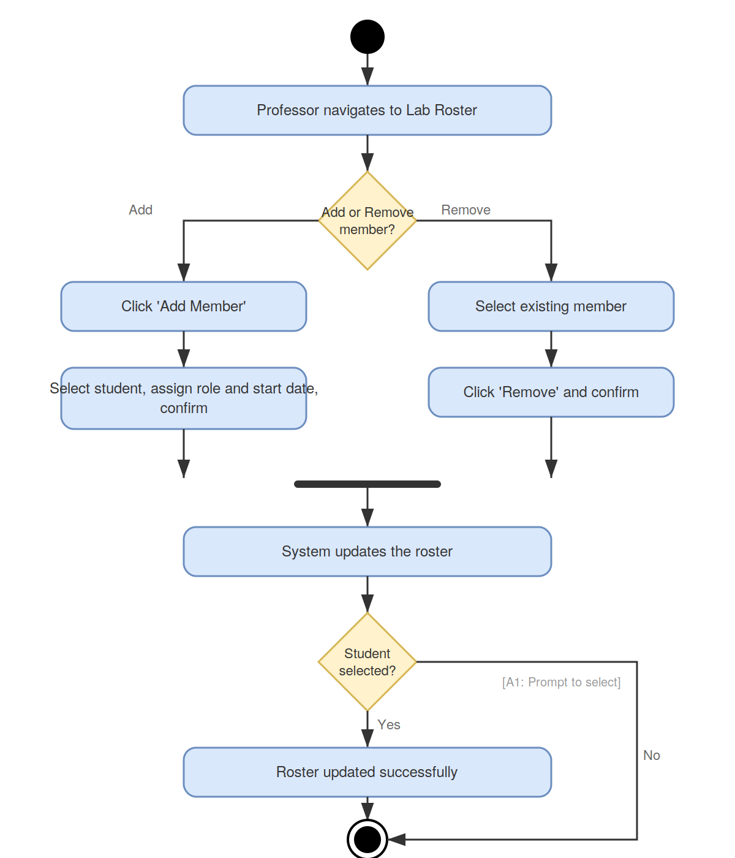

UC_27 – View Applicant History
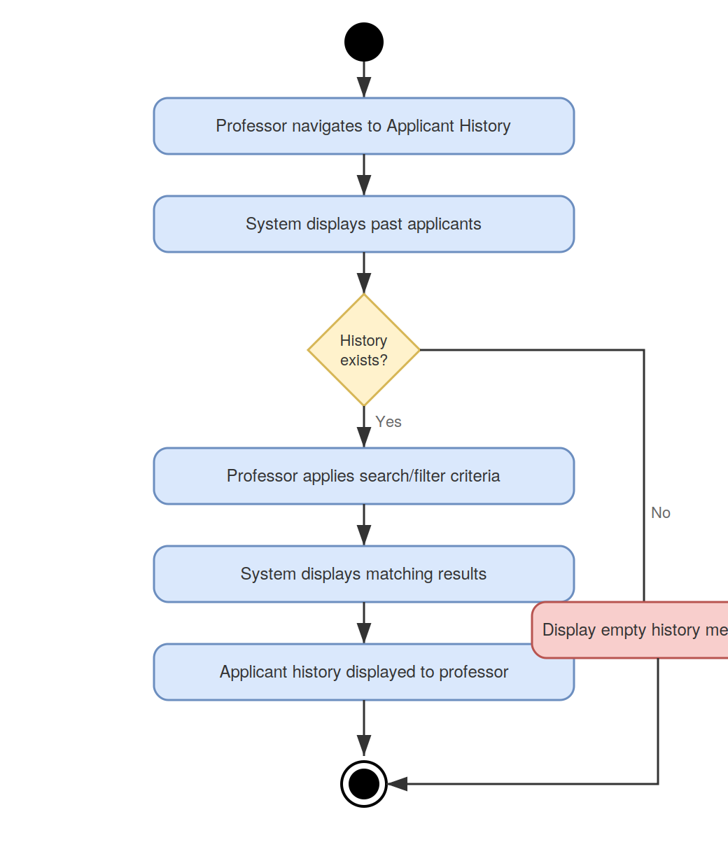

UC_28 – View Application History
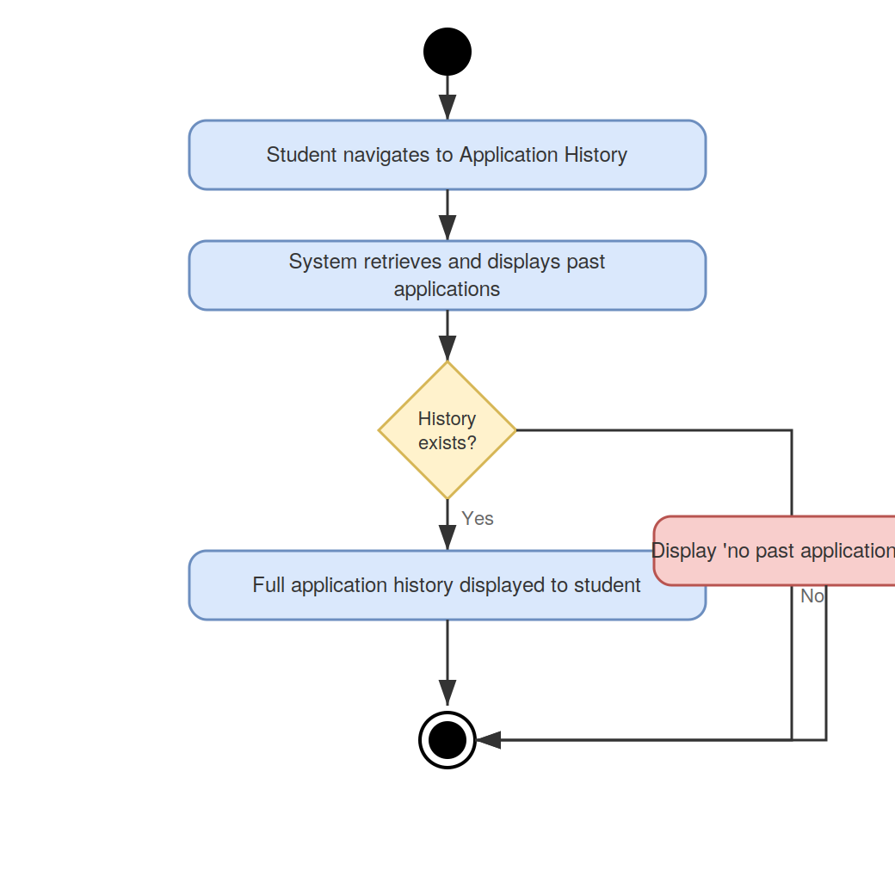

UC_29 – View Feedback
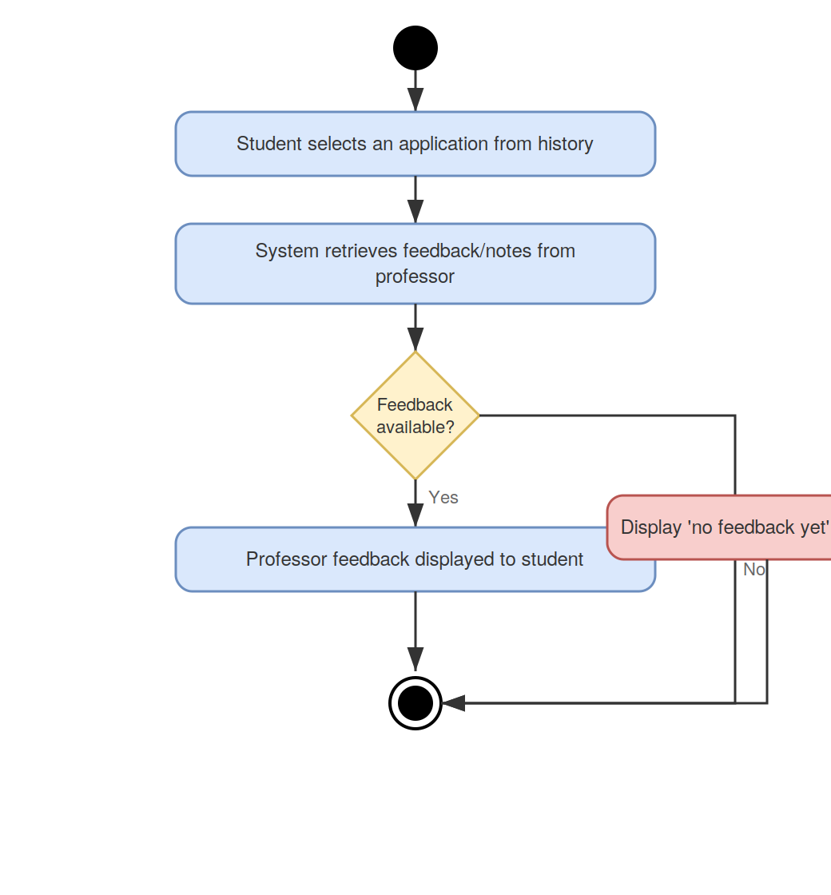

UC_30 – View Funding History
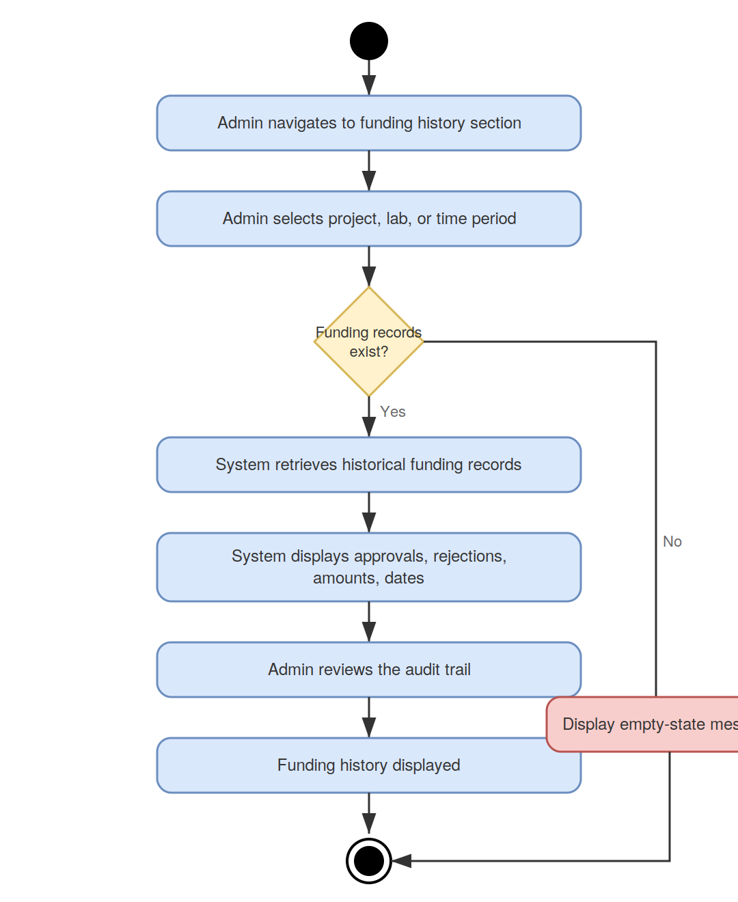

UC_31 – View Lab Safety Compliance Status
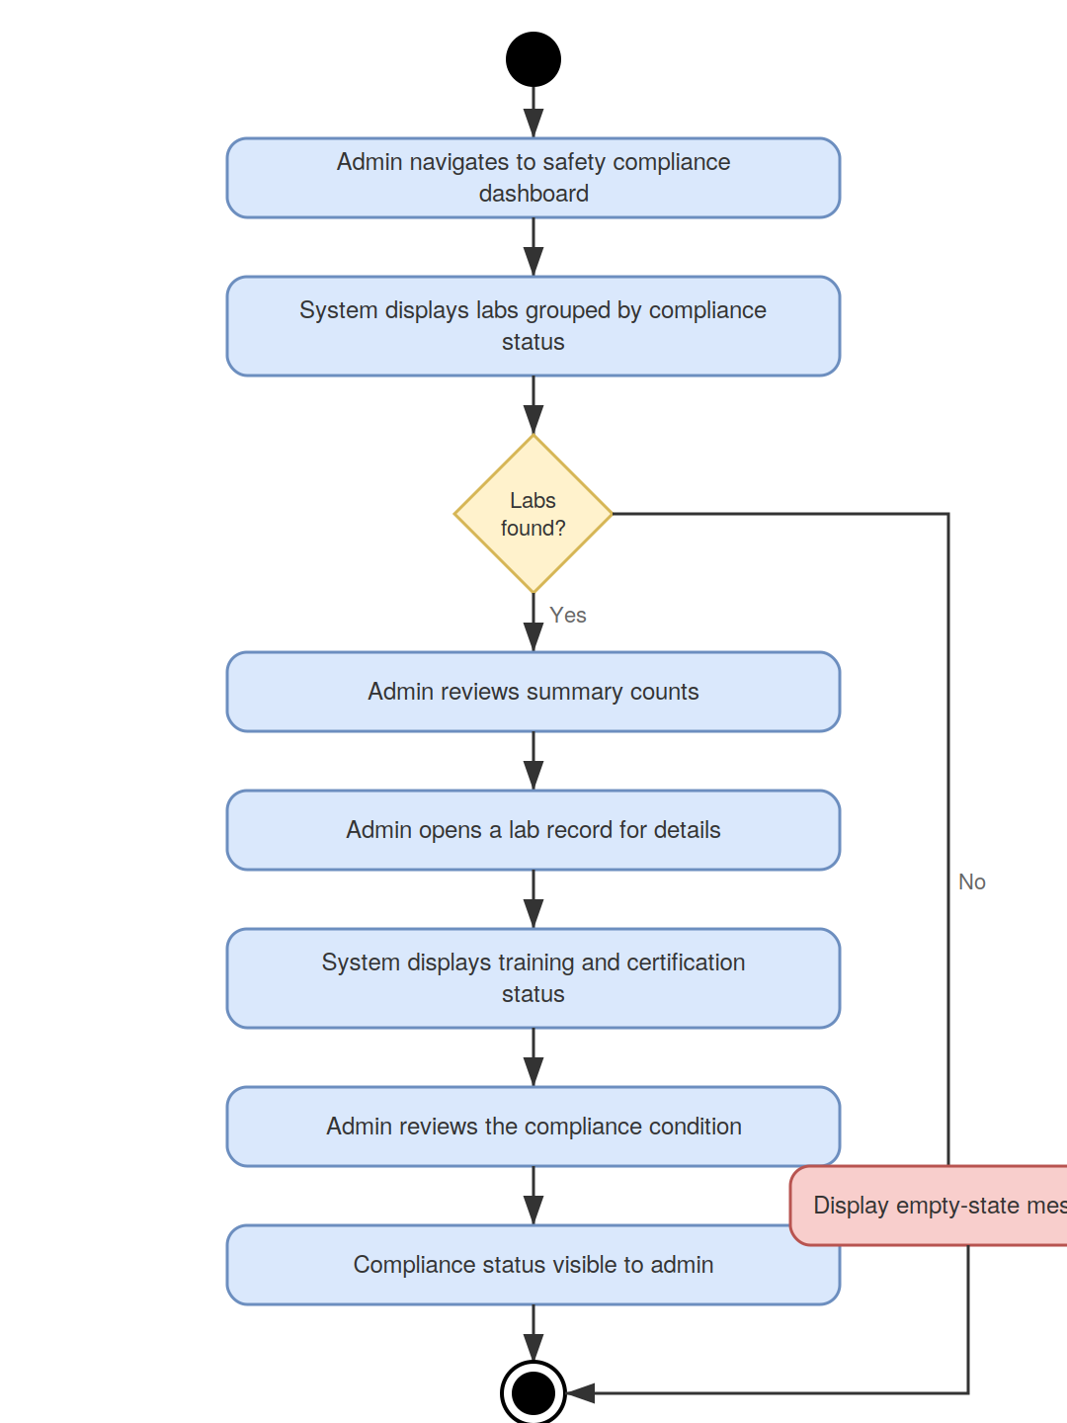

UC_32 – Review Certification Alerts
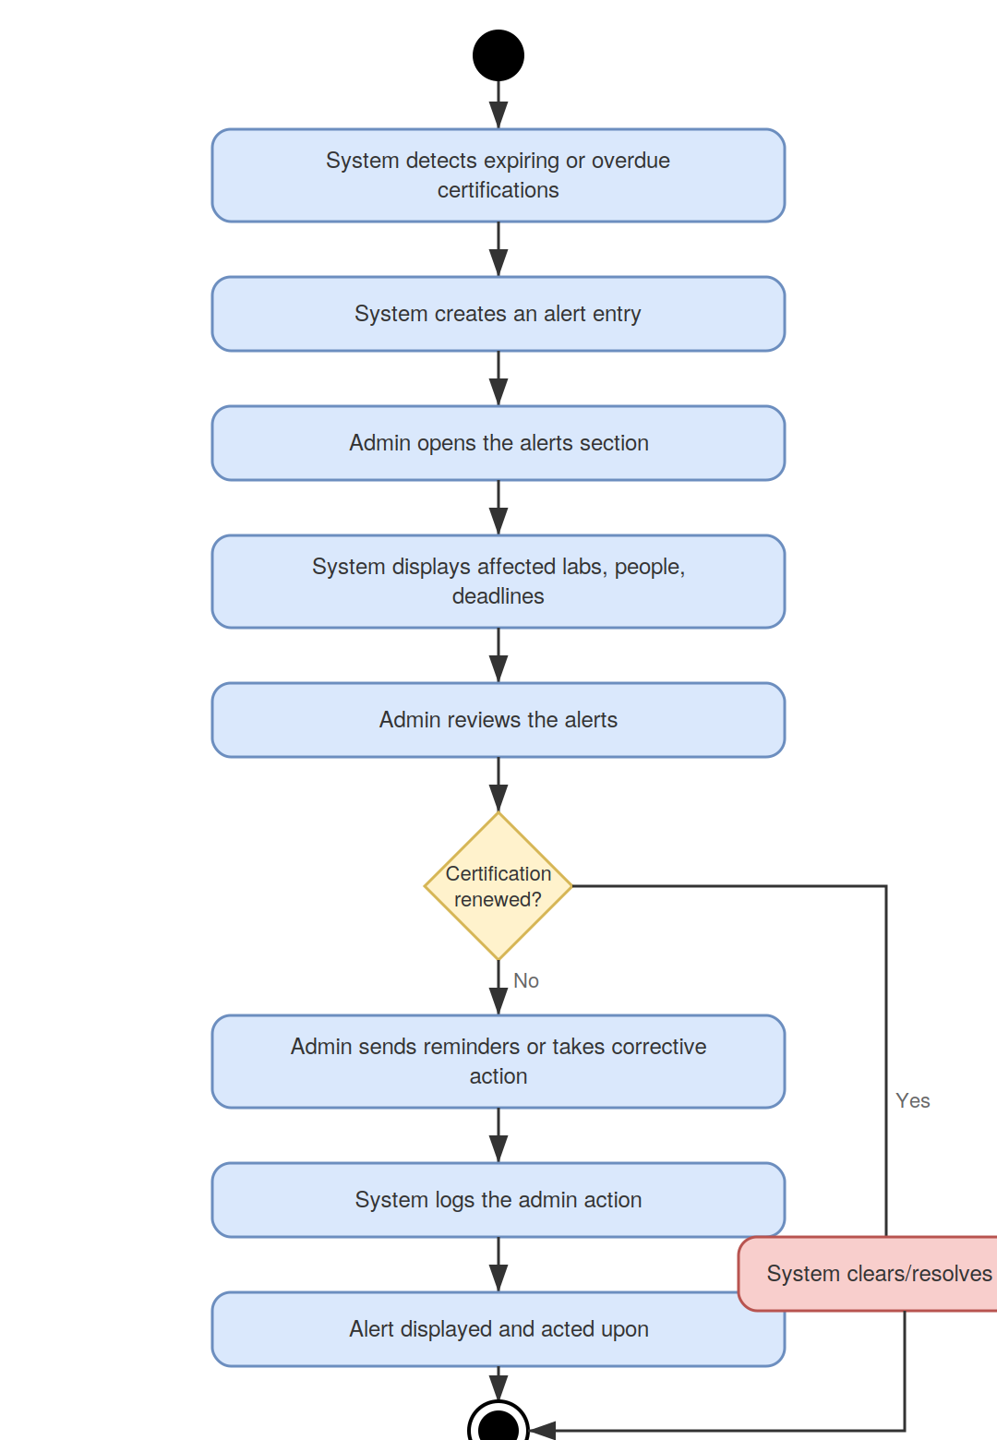

UC_33 – Flag or Restrict Non-Compliant Lab
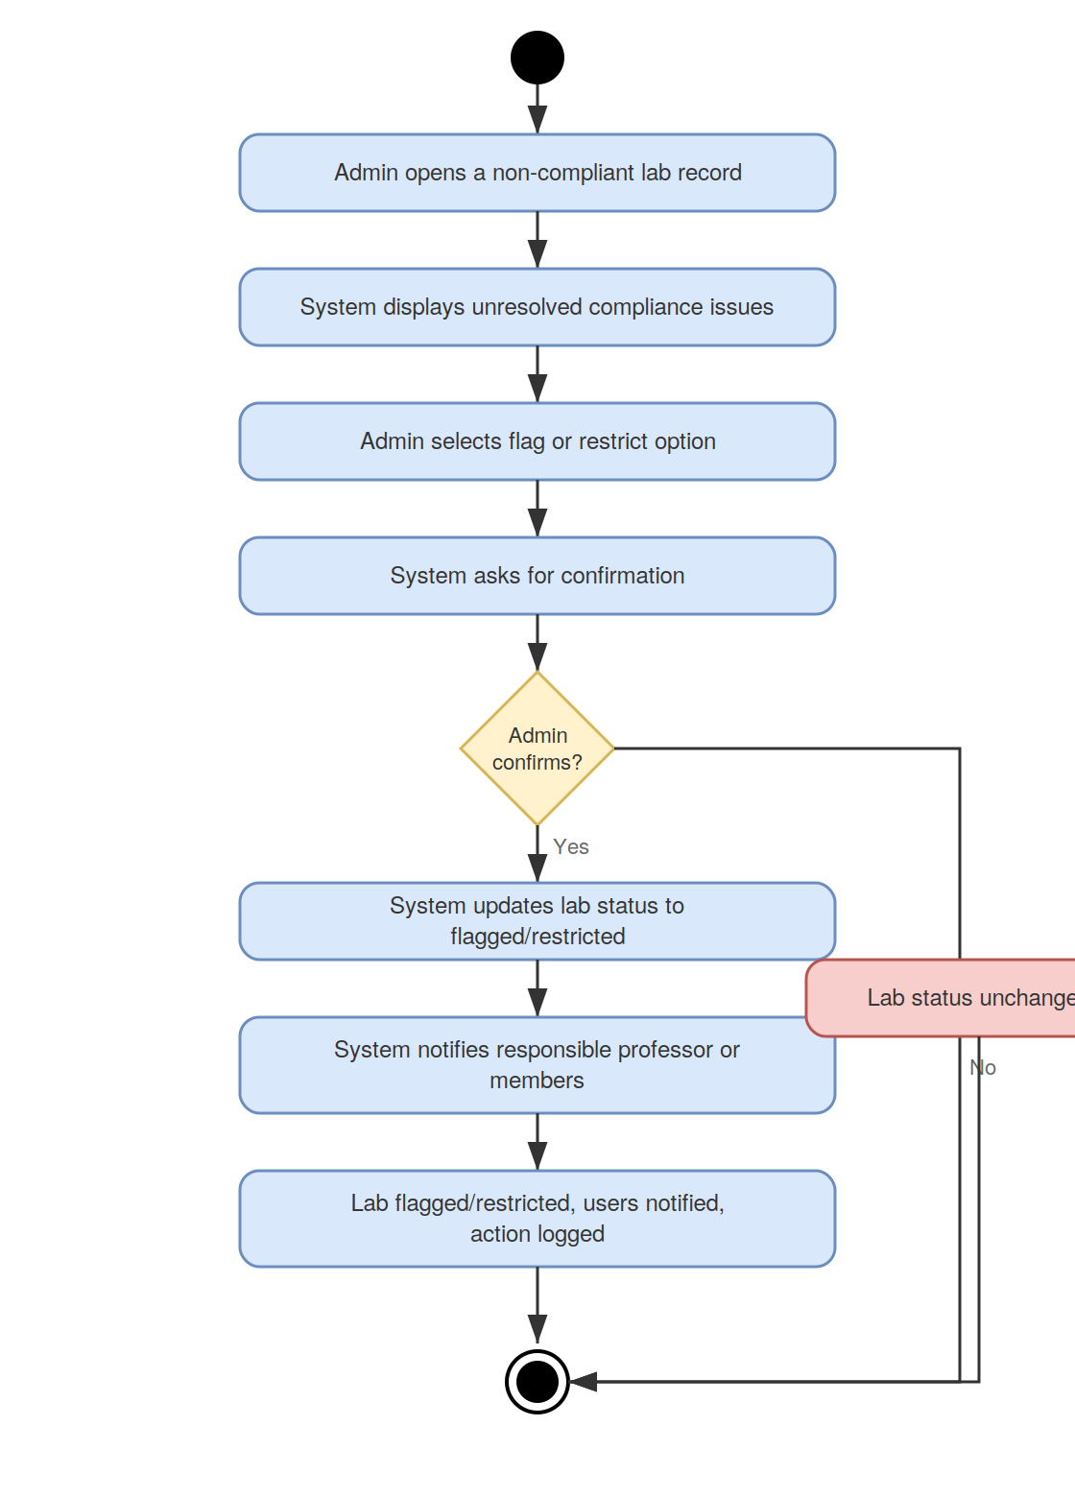

UC_34 – Generate Reports (EPP)
